Children’s Parties

Thank you for enquiring about a children’s party. We provide you with a two hour package which leaves you with a stress free party and have been entertaining children for over 20 years.

During the Magic Show things go from bad to worse for the magician (much to the delight of the children) so much so that he needs their help to make the magic work as it all goes wrong for him. With the children’s help everything works out (in the end) but it’s very interactive and children go away feeling that they did the magic. The magic show is funny from start to finish and by the end all the children want to help the magician. Because it’s fast, fun and exciting the children are transfixed and love every minute of the show.
Money from thin air, here there and everywhere, paintings that colour themselves in by magic, parents stress removed to the delight of the children. To see a short video please look at the home page of www.amigosmagic.co.uk or http://www.youtube.com/watch?v=rop83nx8iRE

If it’s at a birthday party, the birthday child comes up at the end to make sweets for all their friends. After putting in various ingredients (including smelly socks) a racoon appears which causes more mayhem. The racoon then disappears and sweets appear which the birthday child hands out to all their friends. They also receive a laminated certificate which promotes them to magicians assistant.
By handing out the sweets, receiving the certificate it makes them feel special and makes the day all the more memorable for them.

We also have a live white rabbit which appears out of thin air, which the children get to pet/stroke and have their pictures taken with (if they wish), at the end of the show.

The Magic Show is followed by a 10 minute break where the children grab something to eat and drink. Because it’s a party and they are very excited they will have half a sandwich and a mouthful of crisps before they are running around again. The second half is all to music and is in effect a mini disco Firstly they get to have a go with Spinning Plates, where they walk around a course without the plate falling off, learn to pass the plate, balance it and jump it.

This is followed by interactive fun & games along with balloon races. We don’t play elimination games (as this leads to tears) but give prizes to the team or the child that does something first and in this way incorporates all the children all the time. They are then led in couple of dance routines followed by a huge sword battle with balloon swords (that we’ve made in the interval). By the time they go home they have no energy left. If there is time we make individual balloon models as well.

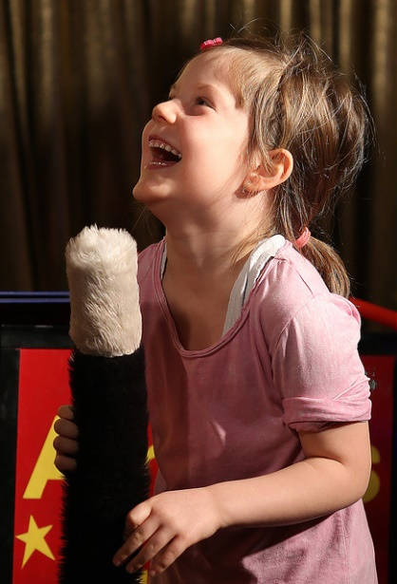
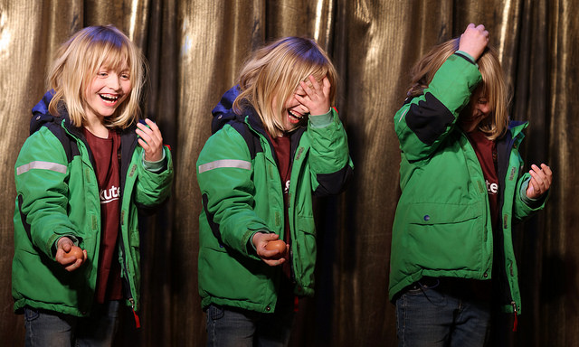
We have public liability and are fully CRB (police) Checked. We are also Members of The Magic Circle & Equity. We also provide magic at weddings, school fairs, fetes and charity events – from close up to cabaret. For any questions please reply by email or visit www.amigosmagic.co.uk for pictures and references. Make your event truly memorable and unforgettable

